
United International University
Department of CSE
Course Code: CSE 4326
Course Name: Microprocessors & Microcontrollers Laboratory
Experiment no: 3
Experiment Name: Simple ESP-32 based IoT Project Where You Can Control LEDs Through a Webpage Over

Submitted by:
Name: Naznin Sultana Tonni(On Behalf of My Team)
Student ID’s:
- Naznin Sultana Tonni(0112330125)
- Raunak Binte Islam Faiza(0112330953)
- Talha Jubayer(0112410062)
- Rokan Uddin(0112330735)
- Atiqur Rahman Atiq(0112330317)
- Fatema Tuz Zohura Rifa(0112330722)
Section: E
Date of Submission:03/10/2026

Objective:
The objective of this experiment is to design and implement a simple IoT-based LED control system using an ESP32 microcontroller. The ESP32 is configured as a web server and connected to a Wi-Fi network. A web page is accessed through the ESP32's IP address to remotely turn two LEDs connected to GPIO 12 and GPIO 14 ON or OFF. This experiment demonstrates basic IoT communication between a web client and a microcontroller through Wi-Fi.
Apparatus/Instruments used in the Lab:
The following hardware and software components were used for the experiment:
- ESP32 Development Board
- Two LEDs
- Two Resistors
- Breadboard
- Jumper Wires
- USB Cable
- Computer/Laptop
- Arduino IDE
- Wi-Fi Network / Mobile Hotspot
- Web Browser
The ESP32, two LEDs, breadboard, jumper wires, USB cable, computer, and current-limiting resistors are the main components specified for the LED webserver project.
Theory:

1. ESP32
ESP32 is a microcontroller development platform with built-in Wi-Fi connectivity, making it suitable for Internet of Things (IoT) applications. Unlike a conventional microcontroller that only controls locally connected devices, the ESP32 can communicate with other devices through a network.
In this experiment, the ESP32 is used as a web server. It receives HTTP requests from a web browser and controls LEDs according to the commands received.

2.ESP32 Web Server
A web server is a system that receives requests from clients and provides responses. In this experiment, the ESP32 itself performs the role of the web server.
The ESP32 creates a server on HTTP port 80 and provides an HTML-based control webpage to a connected computer or smartphone. The user can access this page by entering the ESP32's IP address in a web browser.

3.GPIO Control
GPIO stands for General Purpose Input/Output. GPIO pins can be configured as outputs to control electronic components such as LEDs.
In this experiment:
GPIO 12 → LED 1
GPIO 14 → LED 2
A resistor is connected in series with each LED to limit current and protect the LED. The cathode of each LED is connected to GND.

4.Working Principle
The overall operation can be represented as:
Web Browser → Wi-Fi Network → ESP32 Web Server → GPIO → LED
First, the ESP32 connects to the specified Wi-Fi network. After successfully connecting, it obtains a local IP address. The IP address is displayed through the Arduino IDE Serial Monitor.
The user enters this IP address into a web browser. The ESP32 then serves an HTML webpage containing ON/OFF controls for the two LEDs.
When the user presses an ON or OFF button, the browser sends an HTTP GET request to the ESP32. The ESP32 identifies the requested GPIO and changes its output state accordingly.

Solution of the mentioned problems:

Problem
Design and implement a web-based LED control system using ESP32 where two LEDs can be switched ON and OFF through a webpage over Wi-Fi.

1.Circuit Connection
Two LEDs are connected to the ESP32 as follows:
ESP32 Pin | Component | Connection
GPIO 12 | LED 1 | GPIO 12 → resistor → LED anode
GPIO 14 | LED 2 | GPIO 14 → resistor → LED anode
GND | Both LEDs | LED cathodes → GND

2.Program Development
The ESP32 is programmed using the Arduino IDE. The WiFi.h library is used to establish a Wi-Fi connection. A WiFiServer object is created on port 80 to handle HTTP requests.
The main programming steps are:
- Include the Wi-Fi library.
- Set the Wi-Fi SSID and password.
- Define GPIO 12 and GPIO 14 as output pins.
- Set both LEDs initially to LOW.
- Connect the ESP32 to the Wi-Fi network.
- Obtain and display the ESP32's IP address.
- Start the web server.
- Listen for incoming HTTP requests.
- Identify whether the request is for GPIO 12 or GPIO 14.
10.Set corresponding GPIO HIGH or LOW
11.Display the current LED states on the webpage
The reference implementation uses WiFiServer server(80) and maintains separate state variables for GPIO 12 and GPIO 14.
- Code Section :
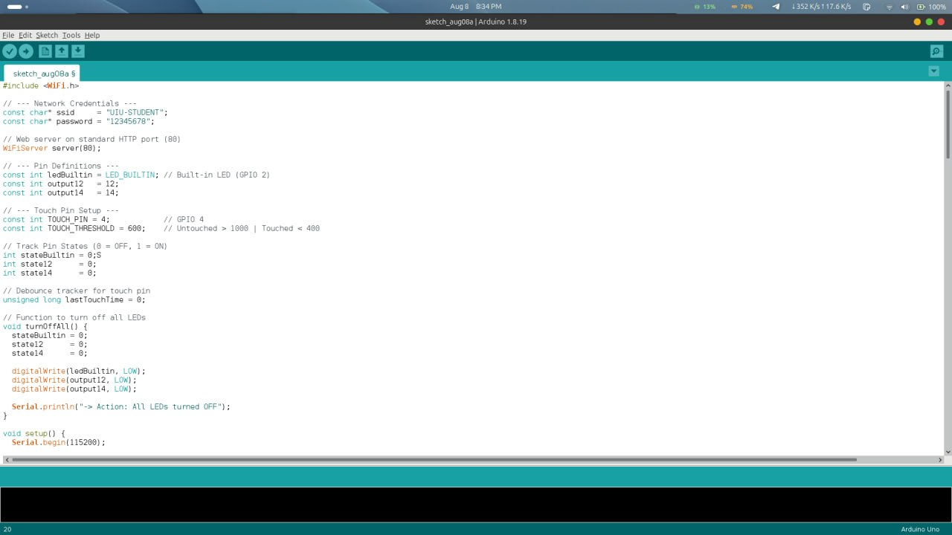

3.Uploading the Program
The following steps were followed to upload the program:
- Connect the ESP32 to the computer using a USB cable.
- Open Arduino IDE.
- Select the appropriate ESP32 board from Tools → Board.
- Select the appropriate COM/serial port.
- Enter the Wi-Fi SSID and password in the program.
- Verify/compile the code.
- Upload the code to the ESP32.
- Open the Serial Monitor.
- Reset the ESP32 if necessary.
10.Wait for the ESP32 to connect to the WiFi.
These steps are consistent with the referenced ESP32 webserver procedure.
4.Finding the IP address
After connecting to Wi-Fi, the ESP32 displays its local IP address in the Serial Monitor.
The actual IP address will depend on the network used during the experiment.
The IP address displayed by the ESP32 is entered into a web browser on a device connected to the same network.
Figure : ESP32 IP address displayed in Serial Monitor
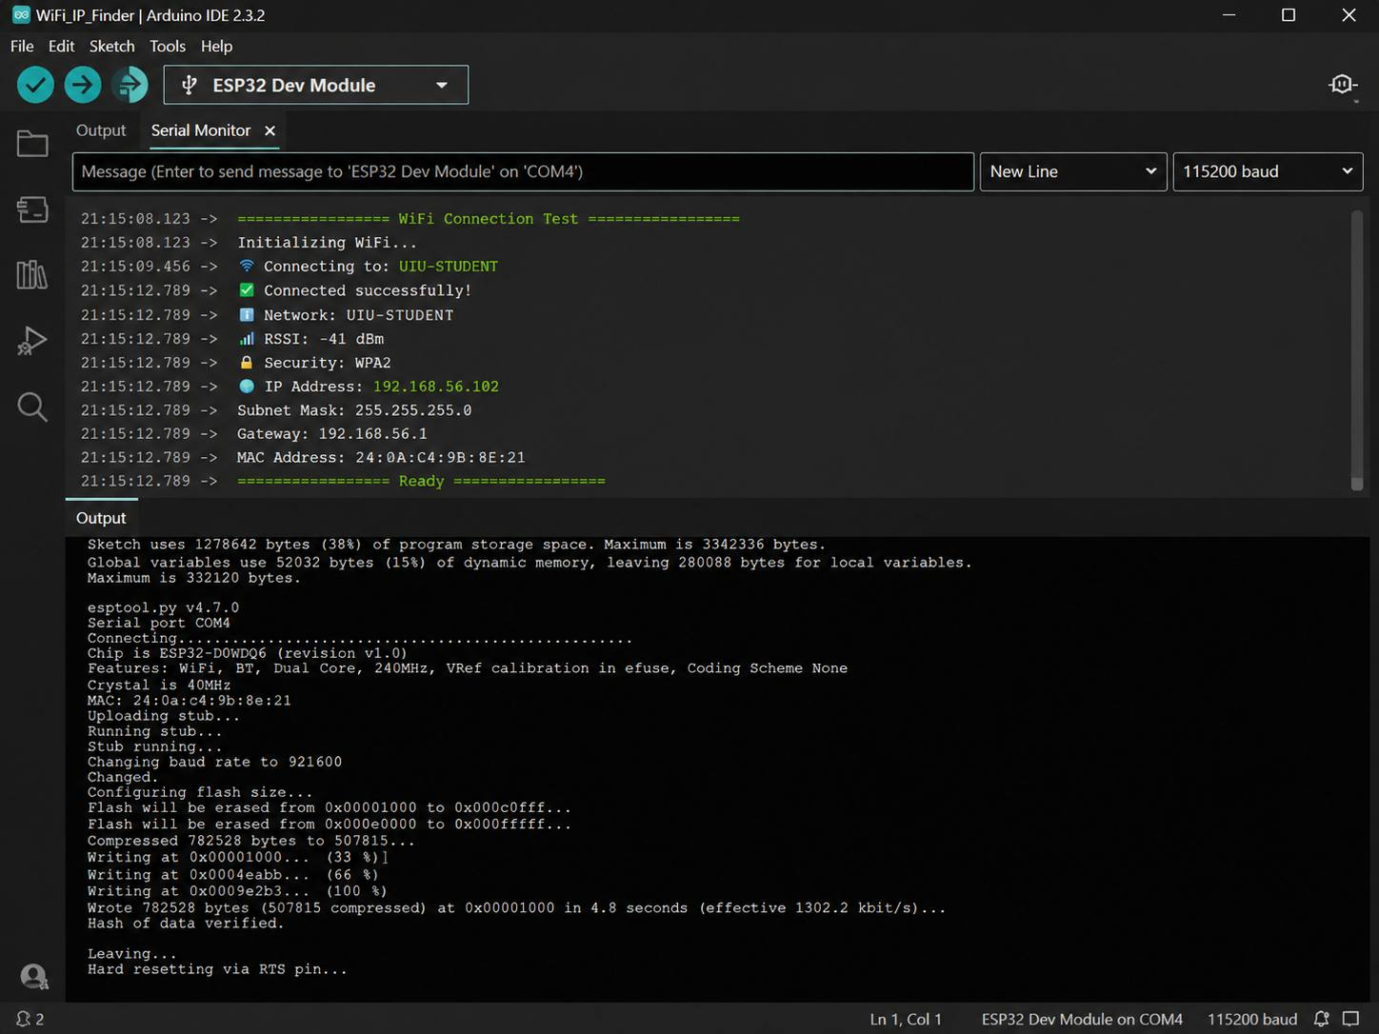
5.Testing the web interface
After entering the ESP32 IP address into the browser, an ESP32 Web Server webpage appears.
The webpage contains controls for:
GPIO 12 — LED 1
GPIO 14 — LED 2
The user can click ON or OFF buttons to control the corresponding LEDs.

Figure : ESP32 LED control webpage
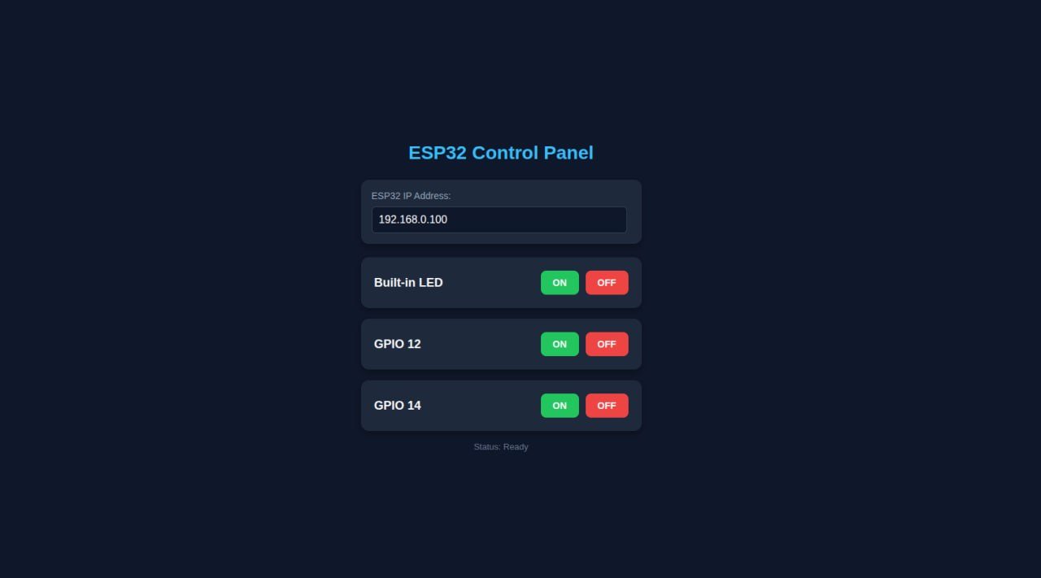
When the GPIO 12 ON button is pressed, an HTTP request such as /12/ON is sent to the ESP32. The ESP32 changes GPIO 12 to HIGH and LED 1 turns ON. Similarly, /12/off turns it OFF. GPIO 14 operates in the same way.
6.Expected output
Action | GPIO 12 LED | GPIO 14 LED
Initial state | OFF | OFF
GPIO 12 ON | ON | OFF
GPIO 12 OFF | OFF | OFF
GPIO 14 ON | OFF | ON
GPIO 14 OFF | OFF | OFF
Both ON | ON | ON
Both OFF | OFF | OFF
The webpage also displays the current state of each GPIO, allowing the user to identify whether each LED is ON or OFF.
Figure : LEDs responding to web-based ON/OFF commands
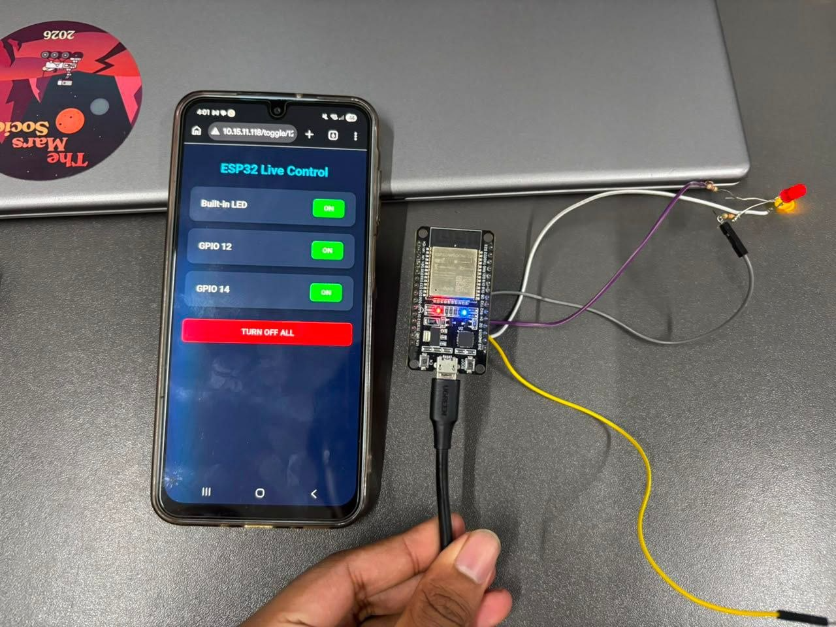
Discussion:
In this experiment, a simple IoT-based LED control system was successfully designed using an ESP32 microcontroller. The ESP32 was configured as a web server and connected to a Wi-Fi network. A web browser was then used as the client to send commands to the ESP32 and control two LEDs connected to GPIO 12 and GPIO 14.
Through this experiment, we learned how a microcontroller can communicate over Wi-Fi and respond to HTTP requests. We also learned how GPIO pins can be controlled remotely through a webpage and how an ESP32 can combine networking and hardware-control functionality in a single device.
During implementation, possible difficulties include incorrect Wi-Fi credentials, selecting the wrong ESP32 board or serial port in Arduino IDE, incorrect LED wiring, and failure to access the ESP32 IP address when the client device is not connected to the same network. The Serial Monitor is useful for checking Wi-Fi connection status and identifying the ESP32's IP address.
This project demonstrates an important basic concept of IoT: controlling physical devices through a network-based interface. The same concept can be extended to practical applications such as smart lighting, home automation, remotely controlled appliances, and other IoT systems.

